Trade of Metal Fabrication
Module 6: | Fabrication Drawing
Unit 2: | Drawing Equipment
 | Phase 2

Table of Contents
List of Figures 5
List of Tables 6
Document Release History 7
Module 6 – Fabrication Drawing 8
Unit 2 – Drawing Equipment 8
Duration – 1 Hours 8
Learning Outcome: 8
Key Learning Points: 8
Training Resources: 8
Key Learning Points Code: 8
Technical Drawing Equipment 9
Introduction 9
Examples of Symbols from BS:308 9
‘A’ Size Drawing Sheets 9
Types of Paper 10
Technical Drawing Instruments 11
A Minimum Set of Technical Drawing Equipment 14
Drawing Sheet Layouts 14
Types of Lettering 16
Lines 17
Storing Equipment and Drawings 18
A Suggested Equipment Tidy Box 18
Dimensions 19
Computer Aided Drawing and Design (CAD) 20
Introduction 20
Why Use CAD? 23
Why Then Learn Technical Drawing? 23
Zoom 24
Cartesian Coordinates 25
An Example of a Drawing with CAD 26
Three-Dimensional CAD 27
Further Examples of CAD Software Packages 27
Self Assessment 29
Answers to Questions 1-3. Module 6. Unit 2 31
Index 34

List of Figures
Figure 1 - BS:308 Technical Drawing 8
Figure 2 - Sizes of an A0 Size Drawing Sheet 8
Figure 3 - Some of the A Size Series of Drawing Sheet 9
Figure 4 - Drawing Board, Tee Square and Two Set Squares 10
Figure 5 - Adjustable Set Square - Can be set to any Angle between 45 Degrees and 90 Degrees 11
Figure 6 - 150mm Compass and a Spring Bow Compass 11
Figure 7 - Positioning the Lead of a Pencil Compass 12
Figure 8 - Sharpening of 2H (or 3H) and HB Pencil Points 12
Figure 9 - 'French Curve' 12
Figure 10 - Metric Radius Curve 12
Figure 11 - Drawing Sheet Layouts Suitable for School or College Technical Drawings 13
Figure 12 - Example of a Drawing Sheet Layout such as would be used in an Engineering Company 14
Figure 13 - Types of Lettering for Technical Drawings 15
Figure 14 - Types of Line for Technical Drawings 16
Figure 15 - Suggested Technical Drawing Equipment Tidy Box 17
Figure 16 - Methods of Dimensioning Technical Drawing 18
Figure 17 - PC (Personal Computer) with a Variety of 'Pointing Devices' set up as a CAD Workstation 20
Figure 18 - Computer Monitor Screen Showing a Drawing Constructed in AutoCAD 20
Figure 19 - Drawing Constructed in the Drawing Editor of AutoCAD 21
Figure 20 - Part of the Drawing of Figure 19 in a 'Zoom' Window 23
Figure 21 - Theory of x,y 2-D Coordinate Geometry 24
Figure 22 - Drawing Constructed in CAD by Typing Coordinate Positions of Points 25
Figure 23 - Drawing Constructed in AutoCAD for Windows 27

List of Tables

Document Release History
Date | Version | Comments
19/02/07 | First draft
12/12/13 | SOLAS transfer

Module 6 – Fabrication Drawing

Unit 2 – Drawing Equipment

Duration – 1 Hours

Learning Outcome:
By the end of this unit each apprentice will be able to:
- Identify, select and use all the drawing instruments connected with this programme and state their proper use and care

Key Learning Points:
Rk Sk | Types of pencils used (Clutch and Ordinary type).
Rk | Types of pen used.
Rk Sk | Tee-square, set squares and protractor.
Rk Sk | Scale rule.
Rk Sk | Compass set and accessories.
Rk Sk | French curves and lettering set.
Rk Sk | Types of drawing boards used.
Rk Sk | Paper sizes and method of fixing to boards.
Rk | New technology used in drawing – CAD.
P | Communication, information gathering and recording.

Training Resources:
- Classroom, drawing boards, tee-squares, scale rule, compass with accessories, French curves and lettering sets, paper, A2

Key Learning Points Code:
M = Maths D= Drawing RK = Related Knowledge Sc = Science
P = Personal Skills Sk = Skill H = Hazards

Technical Drawing Equipment

Introduction
Specific materials and drawing instruments are required in order to undertake technical drawing. As technical drawing is now a universal language it is governed by rules regarding methods of drawing and the symbols used. Those rules and symbols are laid down in ISO (International Standards Organisation) standards. British Standards (BS) follows the ISO standards.

Examples of Symbols from BS:308
BS:308 Engineering drawing practice and BS:1192 are both based on ISO:128 Technical drawings - general principles. Figure 1 shows some examples of symbols from BS:308 Engineering drawing practice. The same symbols would be found in ISO:128 Technical drawings - general principles.
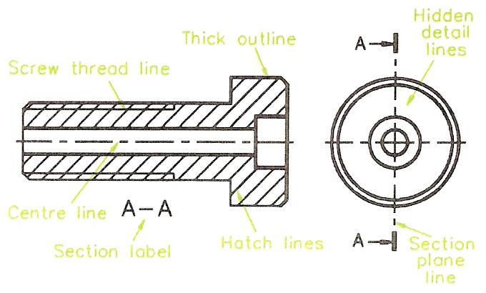
Figure 1 - BS:308 Technical Drawing

‘A’ Size Drawing Sheets
The ISO also specifies an ‘A’ size series of drawing sheets for technical drawings. Figure 2 shows the basic A0 sheet, the area of which is 1 square metre.
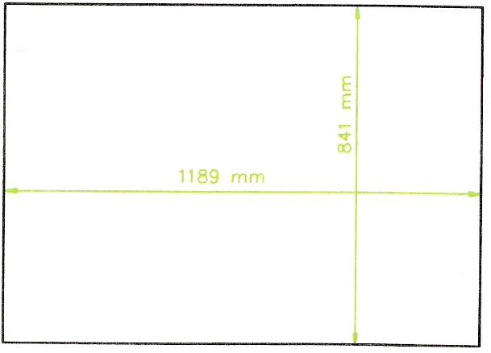
Figure 2 - Sizes of an A0 Size Drawing Sheet
Other A size sheets are A1, A2, A3, A4 and A5. All A size sheets have their edge lengths in the same proportion. This proportion is in the ratio of short side: long side = 1:√2.
Each lower size sheet in the A series is obtained by exactly dividing the A sheet along its middle as shown in Figure 3. This results in the following range of sizes.
A0 = 841 mm X 1189 mm = 1 square metre
A1 = 841 mm X 594 mm
A2 = 594 mm X 420 mm
A3 = 420 mm X 297 mm
A4 = 297mm X 210mm
A5 = 210 mm X 148 mm
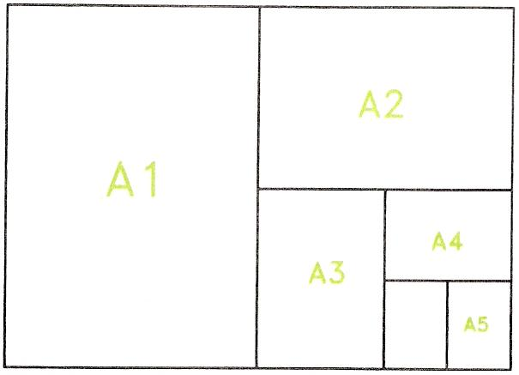
Figure 3 - Some of the A Size Series of Drawing Sheet

There are larger size A sheets (e.g. 2A0, 4A0) and smaller (e.g. A6) than these. In school, college and examination technical drawing the sizes most commonly used are A2, A3 and A4 sheets.

Types of Paper
Papers are commonly measured by their weight - known as so many grams per square metre - gsm. Technical drawing papers are measured in this way. Papers suitable for technical drawings are:
- Cartridge paper - a good quality paper for pencil drawings. A weight often used is 90 gsm, but thinner or thicker cartridge paper may be used. Made from esparto grass.
- Detail paper - a lighter paper for pencil and colour work. A common weight is 50 gsm.
- Grid papers - often of A4 size. Very suitable for the freehand sketching out of a layout for a technical drawing. Square, isometric and perspective grids.
- Tracing paper - 38 gsm to 63 gsm. For making tracings of technical drawings.
- Papers and boards for ink work. If wishing to draw with inks - black and/or coloured inks - a large variety of different papers and boards is available.

Technical Drawing Instruments
The following minimum set of instruments is required in order to construct good quality technical drawings:

- Drawing board - most often made from wood, often from 12 mm thick plywood. Sizes vary, but for school and college work one measuring 650 mm by 470 mm is suitable for working with A2 size (or smaller) papers. The surfaces of all drawing boards should be cleaned at regular intervals, by wiping with paper or cloth and occasionally by re-sandpapering to ensure the surfaces are flat, smooth and clean.
- Fixing sheets of paper to the board - drawing paper can be fixed with pieces of sticky tape - masking tape is the best as well as being the cheapest, although 'Sellotape' type of tape can also be used. Clips are often used in schools. It is best to avoid using drawing pins for this purpose because they tend to damage the corners of the board after long use.
- Tee square - usually made from hardwoods, the best are from mahoganies, but good quality beech squares are suitable. Make sure the blade length is long enough for your board. Tee squares must be kept clean. Wipe regularly with paper or cloth and occasionally plane the drawing edge to keep it straight. Screws holding the blade to the handle may need to be tightened.
- Set squares - two are necessary, unless you have an adjustable square. See Figure 4. A 60,30 and a 45,45 are needed. If you have an adjustable square (Figure 5), it can be adjusted to the angle required, but even then it is also probably best to have a 60,30 and a 45,45 as well in order not to have to keep adjusting your square. Set squares are usually made from plastic and require regular cleaning with paper or cloth.

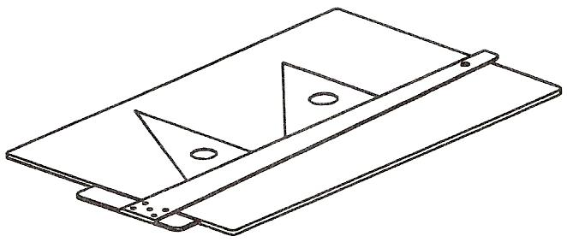
Figure 4 - Drawing Board, Tee Square and Two Set Squares

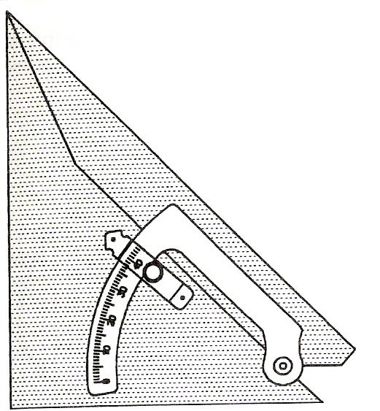
Figure 5 - Adjustable Set Square - Can be set to any Angle between 45 Degrees and 90 Degrees
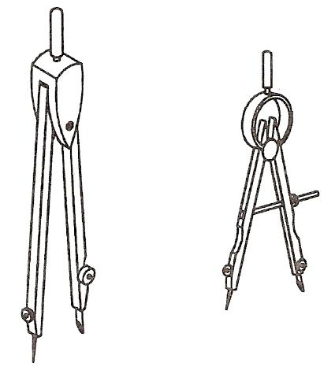
Figure 6 - 150mm Compass and a Spring Bow Compass

- Protractor - for constructing angles, which are not set square angles. A plastic protractor, measuring up to 180 degrees is suitable.
- Compasses and dividers - a good quality pair of compasses, which can draw circles up to 150 mm radius is an essential item of equipment. A pair of smaller 'spring bow' compasses is a valuable asset when drawing circles of 25 mm and less radius. Although not absolutely essential a pair of dividers can prove to be of use at times, e.g. when measuring from another drawing to determine an unknown dimension. See Figure 6. Set the steel point of the compass just a little lower than the tip of the compass pencil. See Figure 7.
- Erasers - essential for correcting mistakes. Vinyl erasers are preferable to rubber erasers - they make a cleaner job of 'rubbing out'. Be careful of rubber dust formed when erasing from a pencil drawing. It can be a source of annoyance causing smudges on your drawings if it is allowed to accumulate unnecessarily.
- Pencils - can be purchased in nine grades of 'hardness' - from H to 9H - and six grades of 'blackness' - from B to 6B. There are also two other grades - F and HB. Two pencils are advisable - a 2H or 3H for drawing with instruments and an HB for freehand drawing such as lettering. Many draughtsmen like to sharpen their 2H pencils to a 'chisel' point and their HB pencils to a round point - Figure 8. Keep your pencils sharp by having either a small smooth file at hand, or a piece of fine sandpaper on which the pencil point can be sharpened as needed.
- Curve aids - 'French curves' and radius curves make the drawing of small radius curves and varied shaped curves much easier.

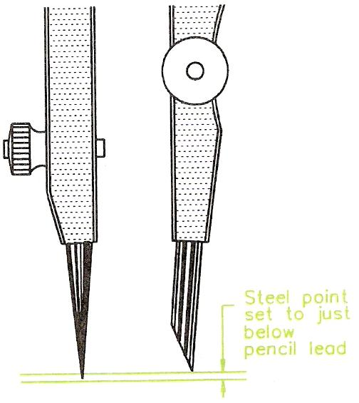
Figure 7 - Positioning the Lead of a Pencil Compass
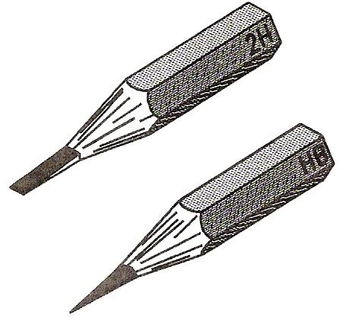
Figure 8 - Sharpening of 2H (or 3H) and HB Pencil Points

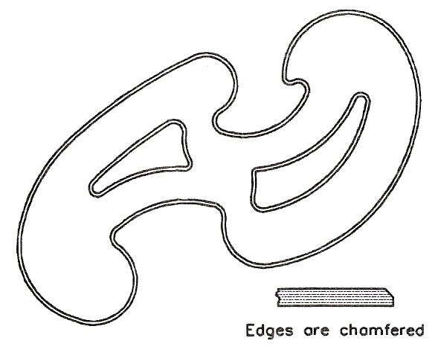
Figure 9 - 'French Curve'
There are many different shapes of these curves. They are chamfered along their upper edges to allow them to be used when drawing with ink pens.

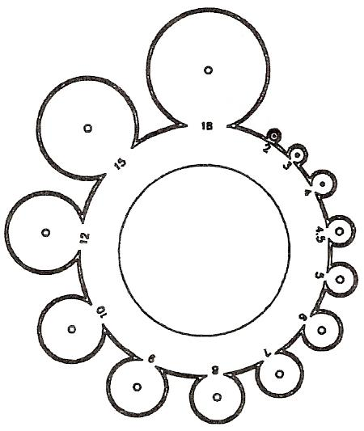
Figure 10 - Metric Radius Curve

A Minimum Set of Technical Drawing Equipment
A minimum set of equipment for the production of good quality drawings would be:
- A drawing board to take A2 paper.
- Strips of masking tape or drawing board clips.
- A Tee square.
- Two set squares.
- A protractor.
- A 150 mm compass and also spring bow compass.
- An eraser.
- Two pencils - a 2H and an HB, together with some sharpening device - file or sandpaper.
- At least a radius curve.

Drawing Sheet Layouts
Figure 11 shows two typical drawing sheet layouts for school or college use when working on A2, A3 or A4 sheets of drawing paper. The sheets can be in either an upright position, which is known as 'portrait' or in a horizontal position, known as 'landscape'. Note the following:
- Border or margin lines: these surround the drawing. For an A4 size sheet these should be set in 10 mm; for an A3 sheet, 15 mm and for A2, 20 mm. The idea of a margin is so that the outer edges of the drawing area are protected if the sheet edges become damaged - at least the drawing area may not be affected.
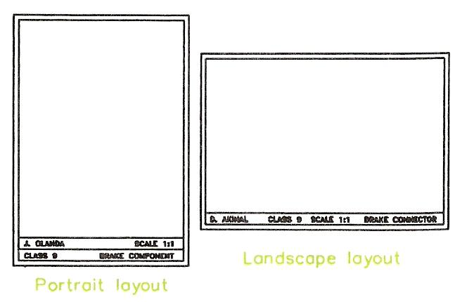
Figure 11 - Drawing Sheet Layouts Suitable for School or College Technical Drawings
- Title block area: the examples in Figure 11 show the portrait layout with a double rectangle and the landscape layout with a single title block. In the title block details such as:
  - Your name.
  - Your class, form or group number.
  - The title of the article being drawn.
  - The scale of the drawing.
- Height of lettering: in title blocks, features such as names, article titles, etc. are usually printed in capital letters. Their height will vary according to the size of the drawing sheet in use. Suggested heights are 6 mm for A4 sheets, 8 mm for A3 sheets and 10 mm for A2 sheets.

Figure 12 shows a type of sheet layout, which may be found in use by engineering companies. The sheets will be pre-printed so that draughtsmen can start working on the sheet without having to add details such as those shown in the title block. Note also the set of reference numbers around the margins of this sheet - anyone using the drawing can indicate any part by reference to the marginal letters and figures.

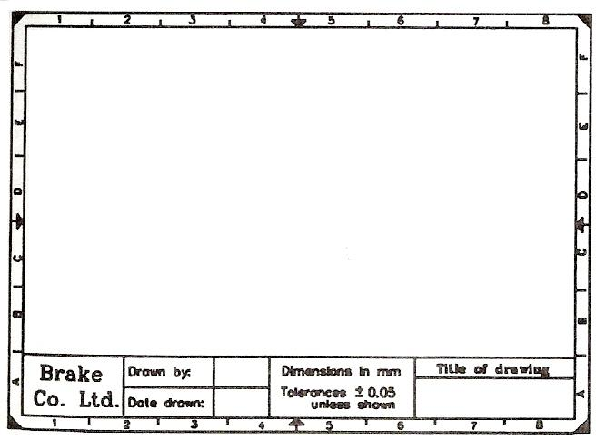
Figure 12 - Example of a Drawing Sheet Layout such as would be used in an Engineering Company

Types of Lettering
Figure 13 shows the type of lettering, which should be used in technical drawings. Lettering should be simple, so that it can be easily read. As mentioned above, the height of letters should vary according to the size of drawing sheet in use. Notes and dimension lettering and figures should be drawn at a lower height than title block lettering. For example, on A4 sheets 3 mm high notes and dimension figures would be suitable; on an A2 sheet a height of 5 or 6 mm would be better.

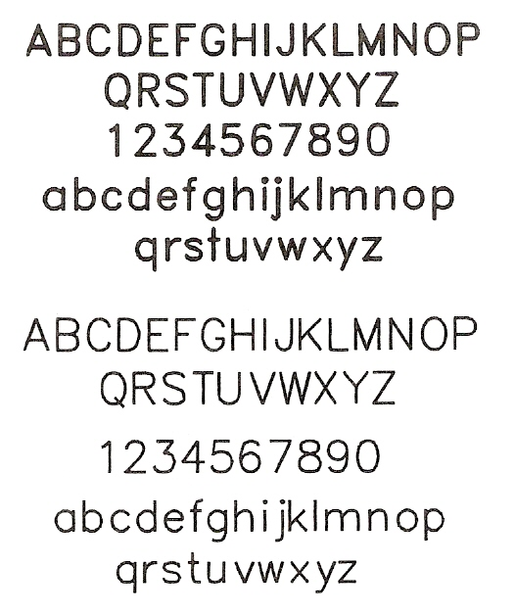
Figure 13 - Types of Lettering for Technical Drawings

Lines
Figure 14 shows some of the types of lines for technical drawings. Note that the lines for the outline of drawings should be thicker than other lines. This makes the outline stand out clearly against the other details in your drawings. BS:308 recommends that outlines should be about twice as thick as other lines.

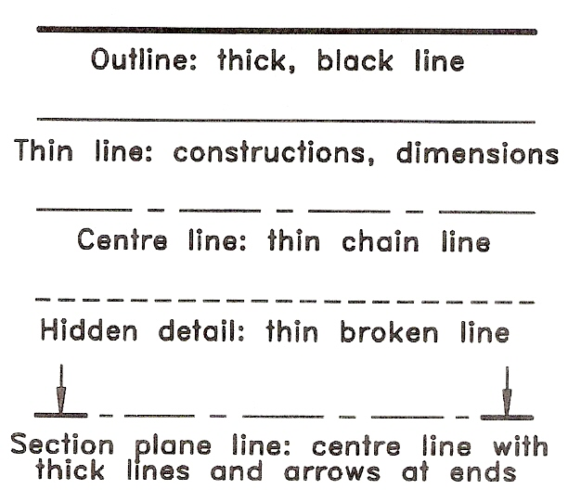
Figure 14 - Types of Line for Technical Drawings

Storing Equipment and Drawings
When a session of drawing is finished, it is important that the equipment, which has been in use, is stored neatly in clean and dry conditions. Dirty and damaged equipment does not help in the production of good, neat and clean drawings. Drawing boards can be either placed in purpose-made racks or stacked one on top of the other. Tee squares should be placed in properly made racks, which make sure that the drawing edges are not damaged and that their two parts do not become separate. Set squares must be kept in a clean condition. They may pick up dust and erasing particles and if they are stored in such a condition other equipment becomes dirty. Pencils can be placed in racks made from blocks of wood with appropriately sized holes. Compasses are easily damaged if not stored properly.
The best method of storing drawings is for each pupil or student to have a folder in which his or her drawings can be placed without their being folded. Other drawings, such as those used to demonstrate the principles of working should be stored flat in drawers large enough to take them unfolded. Take care when placing drawings in folders or drawers. Careless handling can easily cause them to become damaged, even to be torn. Drawings must be kept clean if they are to be read easily.

A Suggested Equipment Tidy Box
Figure 15 shows a box, made from wood and hardboard and designed to hold a set of technical drawing equipment. The main dimensions of the box are:

- Overall length: 330 mm
- Overall depth: 270 mm
- Height: 25 mm
- Thickness of sides: 10 mm

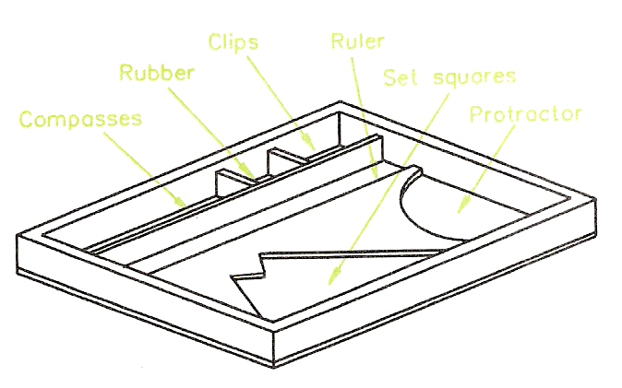
Figure 15 - Suggested Technical Drawing Equipment Tidy Box

Dimensions
Dimensions in technical drawings are very important. Most drawings will require dimensioning, although some drawings of assemblies may not. Without precise and correct dimensioning most drawings are often of little value. Figure 16 shows the ISO:128 methods of dimensioning lengths, circles and arcs. Note the following:
- Dimension lines are thin lines.
- Extension lines are thin lines. Leave a gap of about 3 mm between the drawing outline and the start of the extension line and extend the line about 3 mm beyond the dimension line.
- Arrows should usually be about 3 mm long.
- Other types of 'arrow' will be shown later in this book.
- Figures of dimensions should be about 3 mm high for A4 sheets, 5 mm high for A3 sheets and 6 mm high for A2 sheets.
- Use the abbreviations for circle diameter and circle radius as shown before the figure of the dimension.
- The bottom left drawing shows dimensioning from a datum. All dimensions are taken from the bottom left hand corner of the outline.
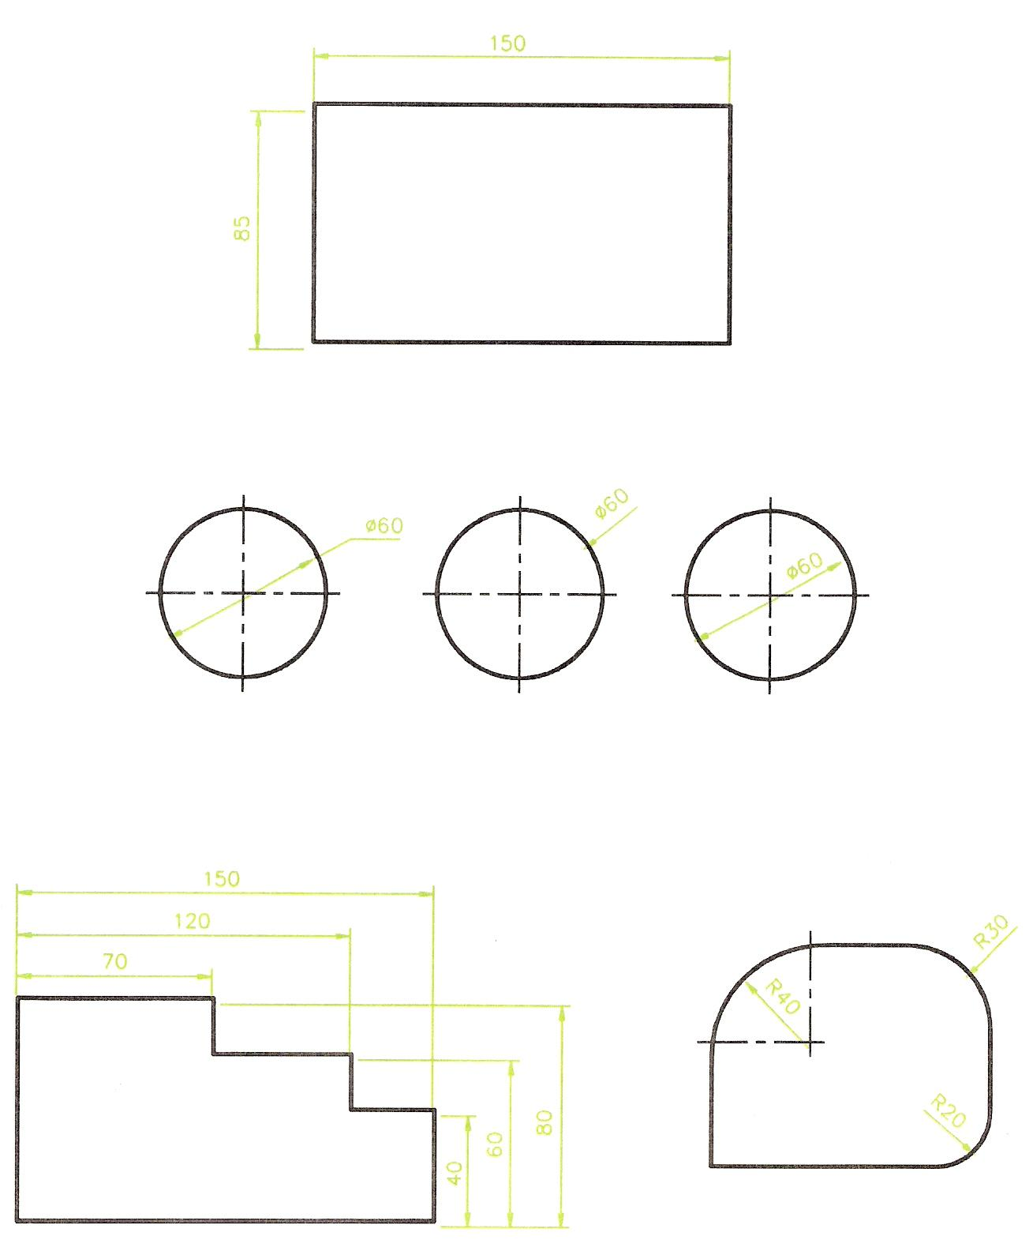
Figure 16 - Methods of Dimensioning Technical Drawing

Computer Aided Drawing and Design (CAD)

Introduction
Technical drawing is the major design method by which ideas about the shape, form, dimensions, materials, machining methods and finishes of articles being made or constructed are passed between those working in the manufacturing and building industries. These industries are increasingly using computers for the production of their technical drawings. It is possible at the present time for a skilled computer operator to be able to design and draw very advanced drawings on a PC (Personal Computer) with the aid of those computer software packages known as CAD (Computer Aided Design). There are many CAD software packages available at the present day for use on a computer, which will stand on the desk of a draughtsman. For the purpose of describing CAD, we will only be dealing with two of these packages. The first AutoCAD - is expensive but is capable of producing any technical drawing, no matter how complicated in the hands of a skilled operator. AutoCAD is by far the most popular of all. There are more CAD workstations equipped with AutoCAD throughout the world than any other package. The second - AutoSketch - is an inexpensive CAD package for constructing 2-D (two-dimensional) drawings. Both packages are produced and sold by the same firm Autodesk.

When working with the aid of CAD, in place of a drawing board, Tee square, other instruments and pencils, drawings are constructed on a computer monitor screen with the aid of the computer keyboard and a hand controlled 'pointing device'. The computer, its monitor, keyboard and pointing device are known as a workstation. See Figure 17.

A typical workstation comprises:
- The computer, its monitor and keyboard. The monitor screen displays the drawing being constructed. The keyboard allows the typing of features such as commands which determine the type of feature being drawn - e.g. LINE, CIRCLE, ARC, or lettering or dimensions.
- A pointing device, which controls the movement of a cursor on the screen. The cursor may be a pair of crossing lines or an arrow. The pointing device may be anyone of:
- A mouse - as the mouse is moved over the desk surface, its movements are followed by the cursor.
- A graphics tablet with a puck. As the puck is moved over the graphic tablet, its movements are followed by the cursor on the screen. The puck can also be used to pick command names, such as LINE or CIRCLE from the graphic tablet.
- A trackerball. Rotation of a ball in its holder causes the screen cursor to move to any required position.
- A joystick with which the cursor is controlled.
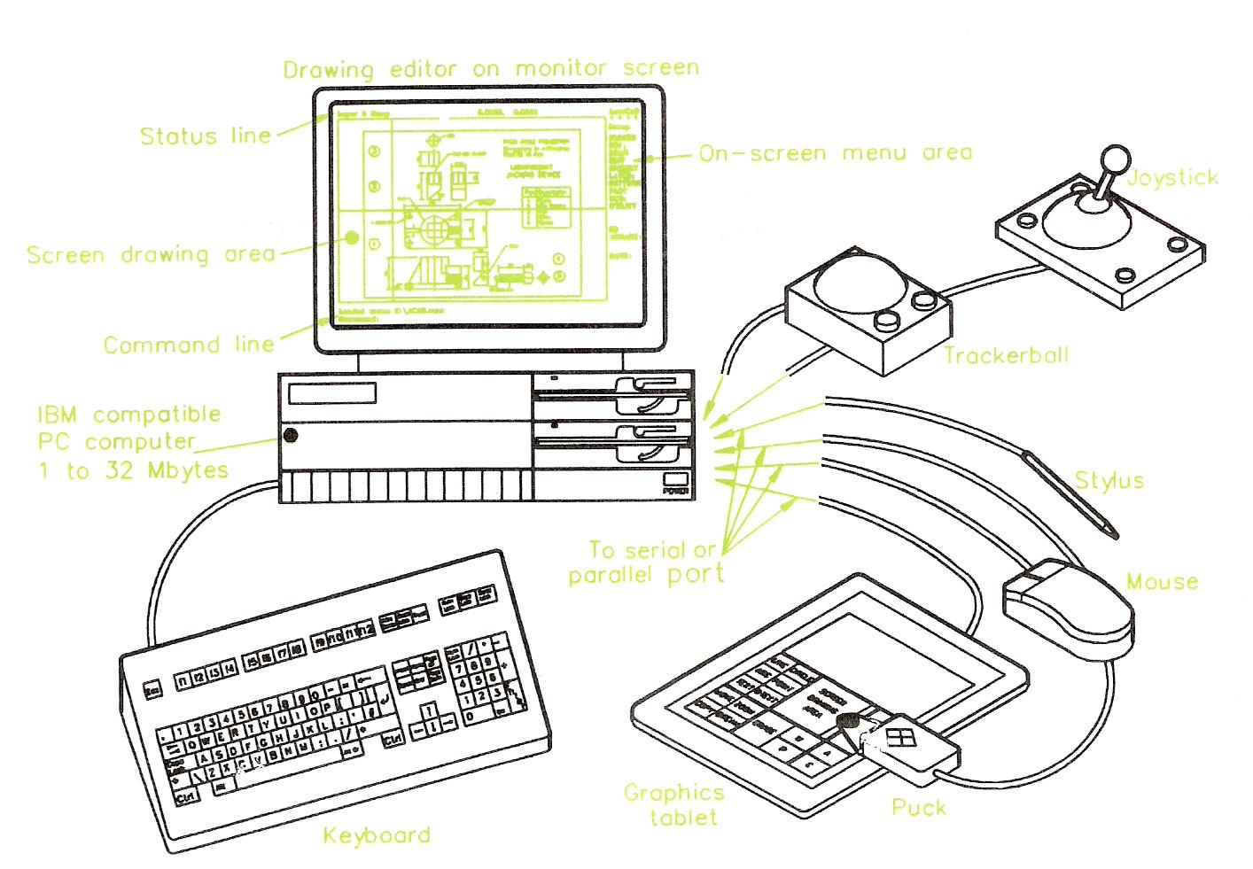
Figure 17 - PC (Personal Computer) with a Variety of 'Pointing Devices' set up as a CAD Workstation

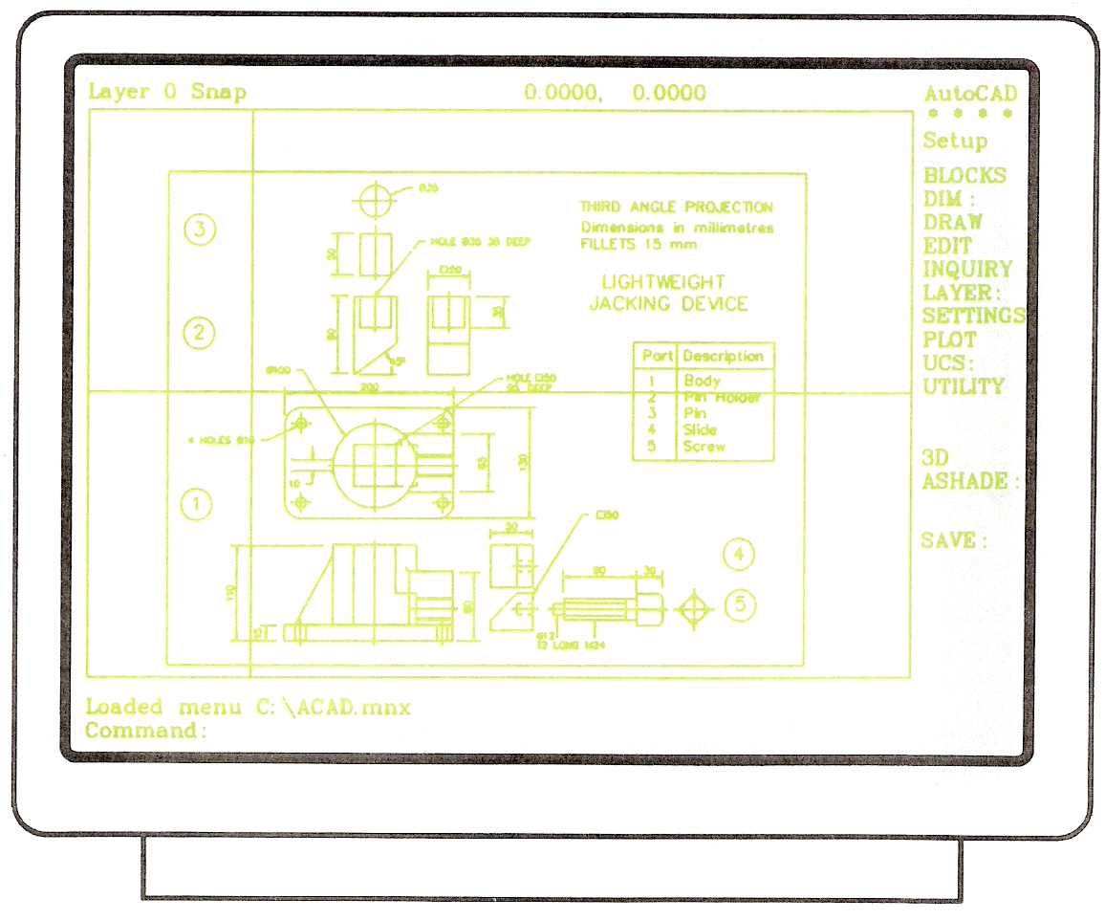
Figure 18 - Computer Monitor Screen Showing a Drawing Constructed in AutoCAD
Only one of these pointing devices is usually fitted to the computer, although some operators prefer to have two fitted so as to be able to use either at anyone time. The monitor screen in Figure 17 shows a drawing in an AutoCAD drawing editor on the monitor screen and Figure 18 shows more clearly details of the drawing in the drawing editor on the screen.

Figure 19 is what is known as a screen dump of the monitor screen shown in Figure 18. It shows what the drawing editor with its drawing actually looks like. Note the following:

- The menu of commands in the right hand column of the screen.
- The pull-down menu showing drawing commands.
- The command line into which commands can be typed from the computer keyboard.
- The menu names along the top edge of the screen.

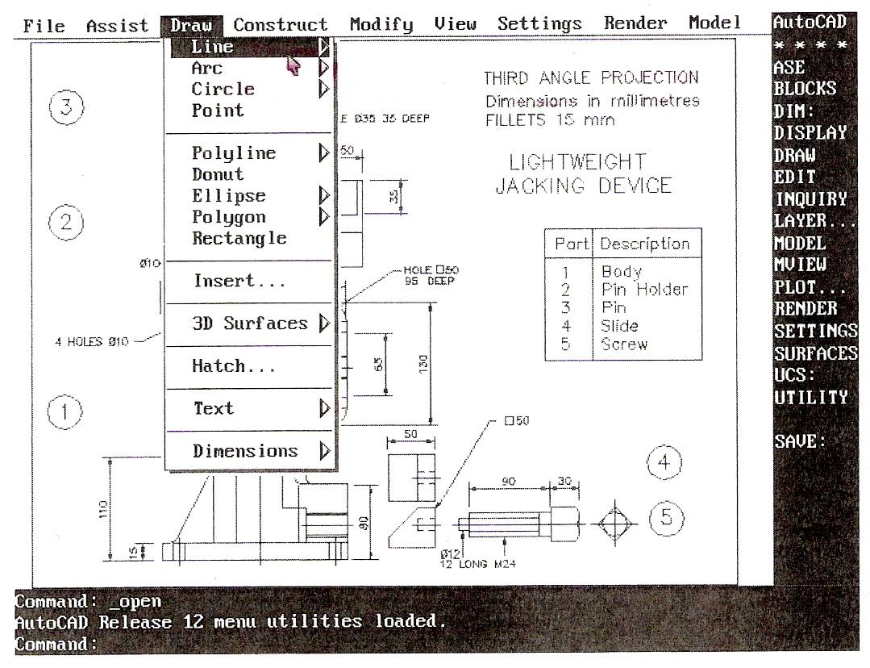
Figure 19 - Drawing Constructed in the Drawing Editor of AutoCAD

Why Use CAD?
There are many reasons why CAD is now being increasingly used in industry:
- Speed of production of drawings. Accurate drawings can be produced by a skilled operator in a tenth (or even less) of the time it takes for a draughtsman to produce the same drawing.
- Drawings or parts of drawings can be placed in other drawings very easily, which saves having to draw the same detail twice. This is one of the major reasons why CAD drawing is so much quicker than drawing by hand. A rule that CAD operators quickly learn is:
Never draw the same thing twice.
- Drawings can be printed or plotted from a drawing on screen with great accuracy. The drawings can be saved to a computer disk to be printed or plotted at any time. Space required to store disks is a fraction of the space required to store drawings on paper.
- Drawings can be printed or plotted from disk to any scale, saving the necessity of having to make up several drawings to different scales for different purposes.
- Parts of drawings can be printed or plotted to any scale, saving the need to re-draw parts of drawings to different scales.
- Parts of drawings can be re-drawn in the case of design changes. Both old and revised drawings can then be saved to disk for recall. When drawing by hand, design changes usually require the whole drawing to be re-drawn.
- Features such as dimensions can automatically be added, ensuring complete accuracy. A good CAD system measures the part that is being dimensioned and then automatically applies that dimension. This avoids dimensioning errors creeping in.

Why Then Learn Technical Drawing?
Even the most skilled computer expert working as a draughtsman with a CAD system must have a good technical drawing background. Without a good knowledge of the practice of technical drawing methods learned 'at the drawing board', a CAD operator cannot produce technical drawings with his/her equipment. It is only by practising with the aid of drawing instruments that computer drawing skills can be gained. A good practical knowledge of plane and solid geometry, an understanding of the theory of orthographic projection, the use of good standard drawing conventions can only be learned by constant practice 'at the drawing board'. So - first learn how to produce good quality technical drawings 'by hand', then learn how to produce them with CAD.

Zoom
One major feature of all CAD software packages is the use of the command ZOOM. A computer monitor screen is smaller than the sheet of paper, which a draughtsman would be using. Because of this when a drawing of say A2 size is on screen, some small parts of the drawing may not be easily drawn. With the aid of ZOOM, even the smallest area of the drawing can be examined and drawn on. Figure 20 shows details from the drawing in Figure 19 after part of the drawing has been placed in a ZOOM window. Note the command and prompt names in the menu on the right of the screen. The prompt Window is highlighted in the zoom menu. A window in CAD terms is a small area from part of the screen.

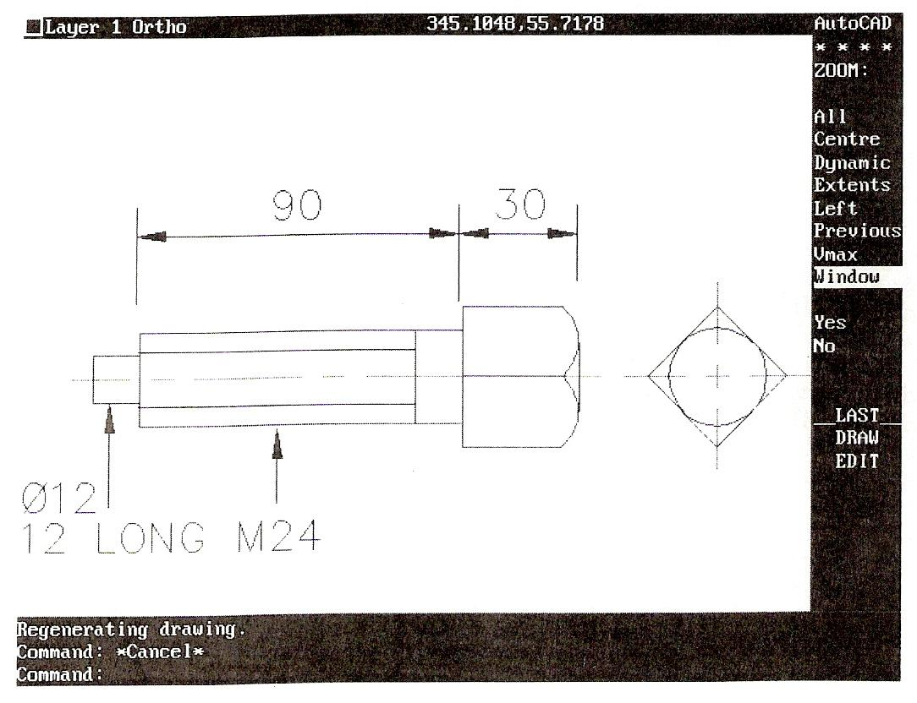
Figure 20 - Part of the Drawing of Figure 19 in a 'Zoom' Window

Cartesian Coordinates
Another feature common to CAD packages is two-dimensional (2-D) coordinates. These allow any point on a screen to be determined in terms of x and y. Units horizontally are in x units, units vertically are in y units. Anyone point on screen is then determined in terms of x,y. If one is working on a screen configured to allow a drawing to be constructed as if on an A3 sheet of drawing paper, the screen would be set so that the drawing editor on screen is 420 units wide and 297 units high (A3 paper is 420 mm by 297 mm). In this case any point on the screen can be determined in units taken from the bottom left hand corner of the screen. Thus the bottom left hand corner is x,y = 0,0; the top right hand corner is x,y = 420,297. Figure 21 shows the x,y positions of four points on a computer screen.

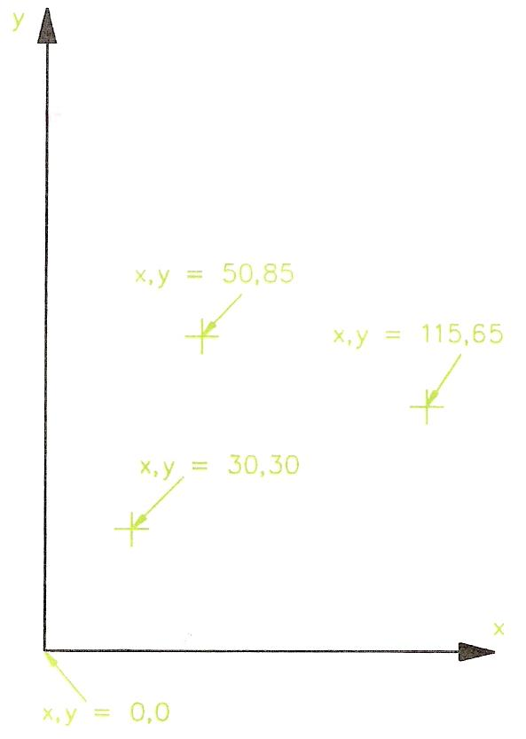
Figure 21 - Theory of x,y 2-D Coordinate Geometry

An Example of a Drawing with CAD
Figure 22 shows a simple line outline within which a circle and a square have been drawn. In a CAD system, a typical method of working to construct this outline could be by typing commands and coordinate numbers at the keyboard. In AutoCAD as the details are typed, they would appear at the command line at the bottom of the drawing editor. In AutoCAD such a sequence would be:

Command: line
From point: 100,200
To point: 250,200
To point: 250,150
To point: 350,150
To point: 350,80
To point: 170,80
To point: 170,150
To point: 100,150
To point: close
Command:
Outline drawn
Command: circle
Circle centre: 130,175
Radius: 25
Circle drawn
Command: line
From point: 300,130
To point: 330,130
To point: 330,100
To point: 300,100
To point: close
Command:
Square drawn

At first glance this sequence may appear to take more time than if the drawing was constructed by hand at a drawing board, but the pointing devices have buttons, which allow rapid changes between the different commands. Also many of the commands are keyed in with a single letter abbreviation - thus LINE is keyed in as 1, CIRCLE is entered as c. The commands can be picked from the menus on the screen - an arrow, moved by movement of the pointing device is placed over a menu name and a pointing device button pressed, which causes the command name to appear in the command line. It is the combined use of a pointing device - mouse, puck, etc. - and entering letters and figures at the keyboard that allows a skilled operator to work very speedily in producing drawings on screen.
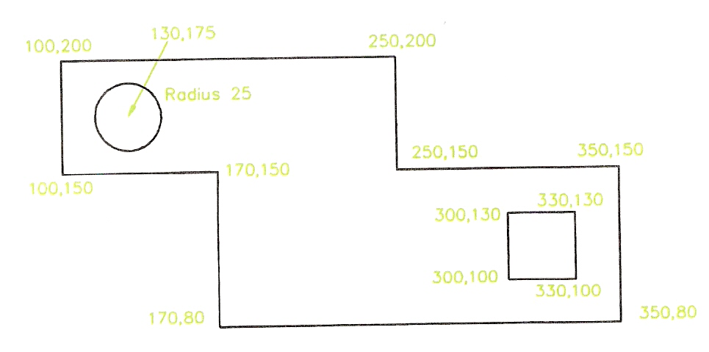
Figure 22 - Drawing Constructed in CAD by Typing Coordinate Positions of Points

Three-Dimensional CAD
It is 3-D (three-dimensional) drawing that CAD excels at in industrial work. In very advanced CAD systems such as AutoCAD (among others), drawings can be produced in 3-D. The 2-D coordinate system is replaced with a 3-D coordinate system with an extra z coordinate - its positive direction is as if it were coming out of the screen towards the operator. It is not so much the value of the actual 3-D drawing that is so important, it is that such 3-D drawings can be shaded and coloured (rendered) to appear as if they were photographs of the component the drawing is portraying. In addition, in engineering industries, the mathematical data for a 3-D drawing held in the computer file for the drawing, can be passed on computer aided machinery and the component actually made in such machines from the data in the file. This method of production is known as Computer Aided Machining (CAM). It must be noted that it is only advanced CAD packages, which can be used for passing data to CAM machinery in this manner.

Note how important the learning of technical drawing skills is. When one has acquired good basic technical drawing skills at the drawing board, this leads onto CAD and CAM in modern engineering industry. In building and architecture similar systems are used. In building the CAD systems are known as Architectural Engineering Computing (AEC) packages.

Further Examples of CAD Software Packages
AutoSketch is a typical 2-D CAD system. Many such packages are available at present and all are relatively inexpensive. They only allow 2-D drawings to be constructed and most work in a similar manner to that already described for drawing in AutoCAD - by selecting or typing commands, followed by selecting points on screen with a pointing device or typing coordinates from the keyboard.
One of the more interesting features in CAD software in recent years has been their development for use in the major software system known as Windows.
Figure 23 is an example of a drawing constructed in the AutoCAD for Windows package.
There are many advantages of drawing with CAD packages developed for working in Windows. Among these are that an operator can work in several computer packages during one session of work. For example:
- Notes can be written in a word processing package.
- Switch to AutoCAD for Windows. Add the note to a drawing.
- Switch to a spreadsheet package. Enter details of a component in the spreadsheet.
- Switch back to AutoCAD for Windows. Add the details from the spreadsheet to the drawing.
- Construct a drawing – say a map showing a friend how to find one’s home.
- Switch to a word processing package and write a letter inviting the friend to your home.
- Switch back to the CAD package and save the map into a Windows style drawing.
- Switch back to the word processor and add the map to your letter.

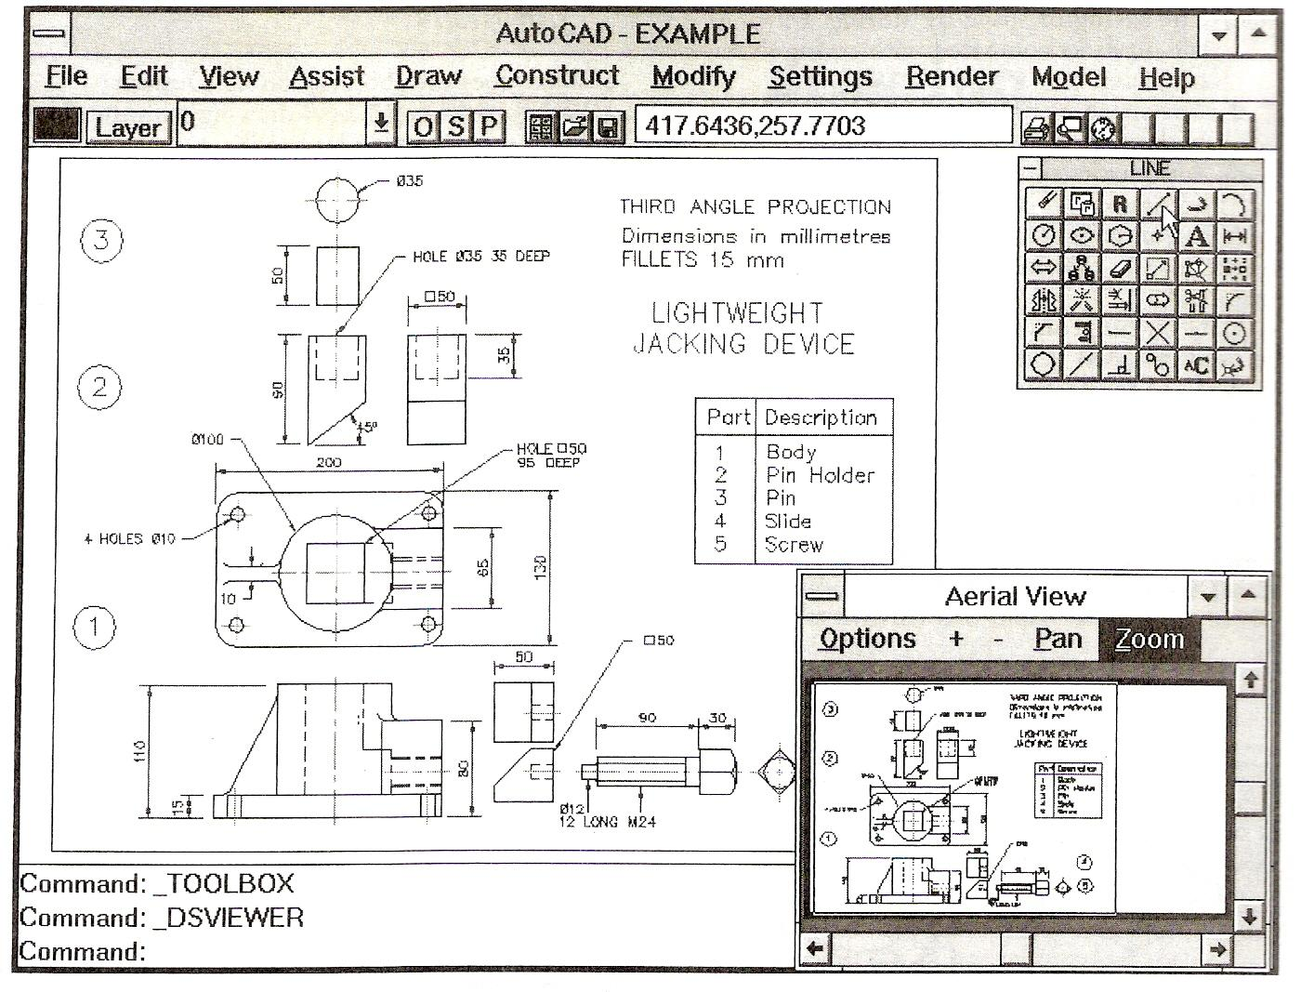
Figure 23 - Drawing Constructed in AutoCAD for Windows

Self Assessment
Questions on Background Notes – Module 6.Unit 2

1. List three main reasons why C.A.D is now vastly used in Industry.

2. When using C.A.D, your workstation consists of a monitor, keyboard and a hand
controlled ‘pointing device’ which controls the curser on the screen, name two of
these devices.

- List one advantage of using Three-Dimensional C.A.D.

Answers to Questions 1-3. Module 6. Unit 2

1.

Computer Aided Drawing: C.A.D

- Accurate drawings can be produced by a skilled operator in a tenth
of the time it takes for a draughtsman to produce the same drawing.

- Drawings or parts of drawings can be placed in other drawings with
ease, which saves having to draw the same detail twice.

- Drawings can be printed or plotted from a drawing on screen with
great accuracy. Drawings can be saved to computer disc, the space
required to store is a fraction of the space required to store drawings
on paper.

2.

Pointing device:

Mouse:
As the mouse is moved over the desk surface, its movements are
followed by the cursor.

Graphics Tablet with a Puck:
As the puck is moved over the graphic tablet its movement are
followed by the cursor on the screen. The puck can also be used to
pick command names such as Line or Circle from the graphic tablet.

Trackerball:
Rotation of the ball in its holder causes the screen curser to move to
any required position.

Joystick:
The curser is controlled by the movement of the joystick.

3.

Three-Dimensional C.A.D:

The 2-D coordinate system is replaced with 3-D coordinate system
with an extra z coordinate – its positive direction is as if it were
coming out of the screen towards the operator.

3-D drawings can be shaded and coloured (rendered) to appear as if
they were photographs of the component the drawing is portraying.

In engineering industries, the mathematical data for a 3-D drawing
held in the computer file for the drawing, can be passed onto computer
aided machinery and the component actually made in such machines
from the data in the file. This method of production is known as
Computer Aided Machining - C.A.M.

Index

C
Computer Aided Drawing and Design (CAD), 19
An Example of a Drawing with CAD, 25
Further Examples of CAD Software Packages, 26
Introduction, 19
Three-Dimensional CAD, 26
Why Then Learn Technical Drawing?, 22
Why Use CAD?, 22
Zoom, 23
S
Self Assessment, 28
T
Technical Drawing Equipment, 8
A Minimum Set of Technical Drawing Equipment, 13
A Suggested Equipment Tidy Box, 17
Dimensions, 18
Drawing Sheet Layouts, 13
Examples of Symbols from BS
308, 8
Introduction, 8
Lines, 16
Storing Equipment and Drawings, 17
Technical Drawing Instruments, 10
Types of Lettering, 15
Types of Paper, 9
Z
Zoom
Cartesian Coordinates, 24

